Comparative evaluation of immunofluorescence in different anatomical sites of brain in canine rabies by direct fluorescent antibody test
Abstract
Rabies is an acute fatal encephalitis known to mankind ever since the dawn of human civilization. Dogs act as the principal vector for transmission of rabies in India. Direct fluorescent antibody test on brain sample is the gold standard test recommended for diagnosis of rabies. The present study was designed to compare immunofluorescence for rabies in different anatomical sites of brain by employing direct fluorescent antibody test (DFAT). Impression smears from cerebrum, cerebellum, hippocampus and brainstem of 30 rabies positive dogs were subjected to grading and comparative evaluation of immunofluorescence upon DFAT. The impression smears from these sites were subsequently graded from 1+ to 4+ based on intensity and distribution of fluorescence. The results revealed that brainstem and cerebellum showed almost similar and higher grades of fluorescence followed by hippocampus and cerebrum. The study also unveiled unilateral distribution of viral antigen in the hippocampus in certain cases which questions the reliability of employing hippocampal smears for DFAT. The study concluded that brainstem and cerebellum are the preferred samples for DFAT for rabies in canines.
Keywords: Rabies, DFAT, grading, immunofluorescence
Running title: Grading of immunofluorescence in rabies

Rabies is one of the oldest diseases known to mankind ever since the dawn of human civilization. This acute encephalitis is caused by a neurotropic, negative sense, non-segmented, single-stranded RNA virus belonging to the Lyssavirus genus of the Rhabdoviridae family and Mononegavirale order (Dupont and Earle, 1965). Street dogs act as the principal reservoirs for rabies in India (AravindhBabu et al., 2012) and canine rabies virus variants are the primary circulating viruses in India that transmit the disease to other domestic animals and humans. Clinical signs shown by animals are not always a reliable indicator of rabies. Hence confirmations based on different laboratory techniques are essential. Direct fluorescent antibody test on brain sample is the gold standard test recommended for diagnosis of rabies. The present study was designed to compare immunofluorescence in different anatomical sites of brain upon DFAT in rabies.
Carcasses of 30 dogs that were diagnosed as rabies positive by DFAT formed the material for the present study. Impression smears from cerebrum, cerebellum, hippocampus and brain stem were collected and subjected to DFAT for grading of immunofluorescence. Based on the intensity and distribution of immunofluorescence, different grades from 1+ to 4+ were assigned as per the protocol recommended by Rupprecht et al. (2018). Before arriving at the conclusion, the fields were scanned under 10X and 40X objectives by at least two pathologists in a blinded manner.
The study analysed grades of immunofluorescence exhibited by different anatomical sites of brain in rabies positive canine carcasses. Various studies have shown that clinical signs are never conclusive in diagnosis of rabies (Hemachudha et al., 2002). According to Shruthi et al., (2022), the animals with history of neurological manifestations need to be screened for rabies by DFAT. As per the observations of Chandran et al. (2022), examination of brain by DFAT is mandatory before declaring that the animal is not rabid. Immunofluorescence obtained from different parts of brain vary widely in distribution and intensity and hence examining brain tissues from various parts of brain is mandatory in the confirmatory diagnosis of rabies.
Grading of immunofluorescence from different parts of brain revealed that both brainstem and cerebellum exhibited relatively higher grade (3+) of fluorescence compared to hippocampus (2+) and cerebrum (1+) in majority of the samples. The immunofluorescence was stronger and almost similar for brainstem and cerebellum followed by hippocampus and cerebrum respectively. The findings were consistent with that of God'spower et al. (2018) who noted that majority of positive samples showed characteristic apple green fluorescence on impression smears from cerebellum, brain stem and hippocampus. The degree of fluorescence exhibited in different grades is depicted in Fig. 1-4.
Occasionally, in a few positive cases, immunofluorescence on hippocampus could be detected only unilaterally. The findings question the reliability of employing impression smears from hippocampus for confirmatory diagnosis of rabies and indicates the need for examining impression from different areas of brain simultaneously to diagnose the disease.
The observations made in the current study recommend brain stem and cerebellum as the preferred samples for diagnosis of rabies in canines by DFAT. Similar observations were made by Tepsumethanon et al. (1997) who observed higher sensitivity for DFAT in brain stem and cerebellum. However, immunofluorescence studies conducted on brain stem, hippocampus and cerebellum by Raju et al. (2008) revealed stronger fluorescence in brain stem followed by hippocampus and cerebellum. The findings by Dumrongphol et al. (1996), who observed maximum viral load in brainstem during early stage of infection, substantiates the results of our study.

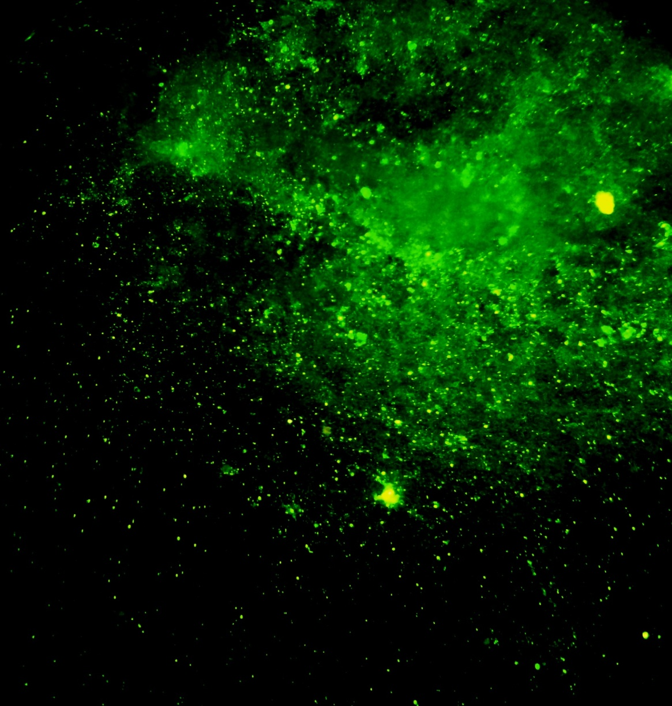
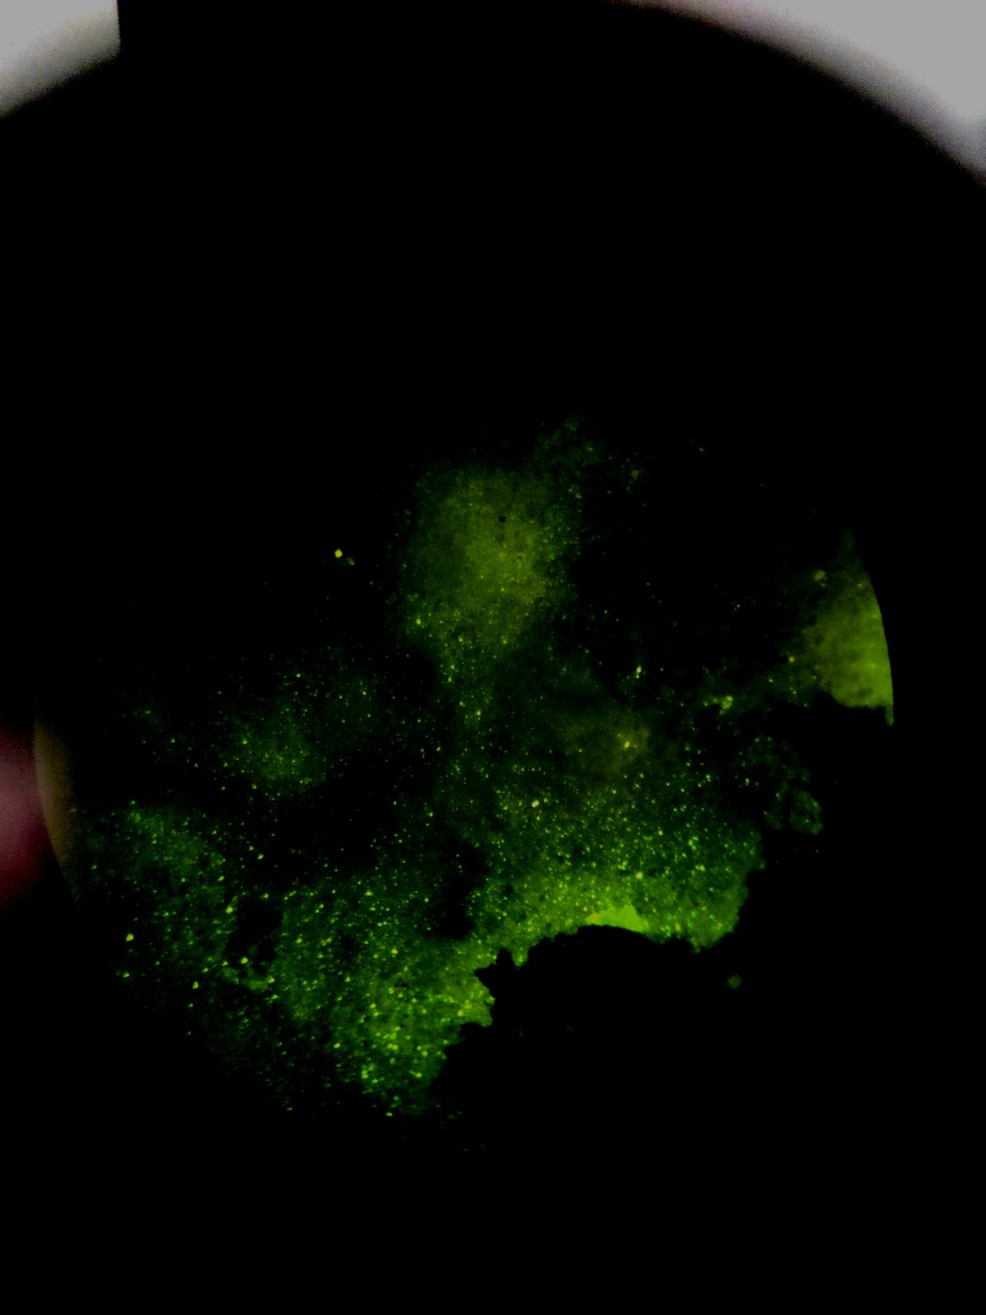

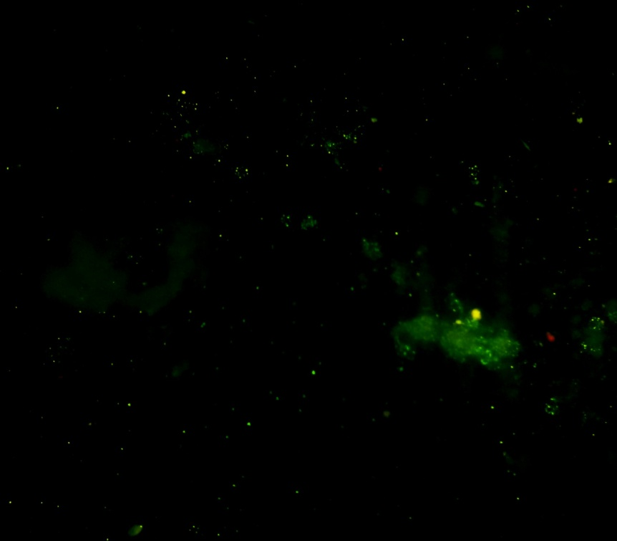
Fig.1. Immunofluorescence for rabies graded as 4+ (DFAT X 100)

Fig.2. Immunofluorescence for rabies graded as 3+ (DFAT X 100)

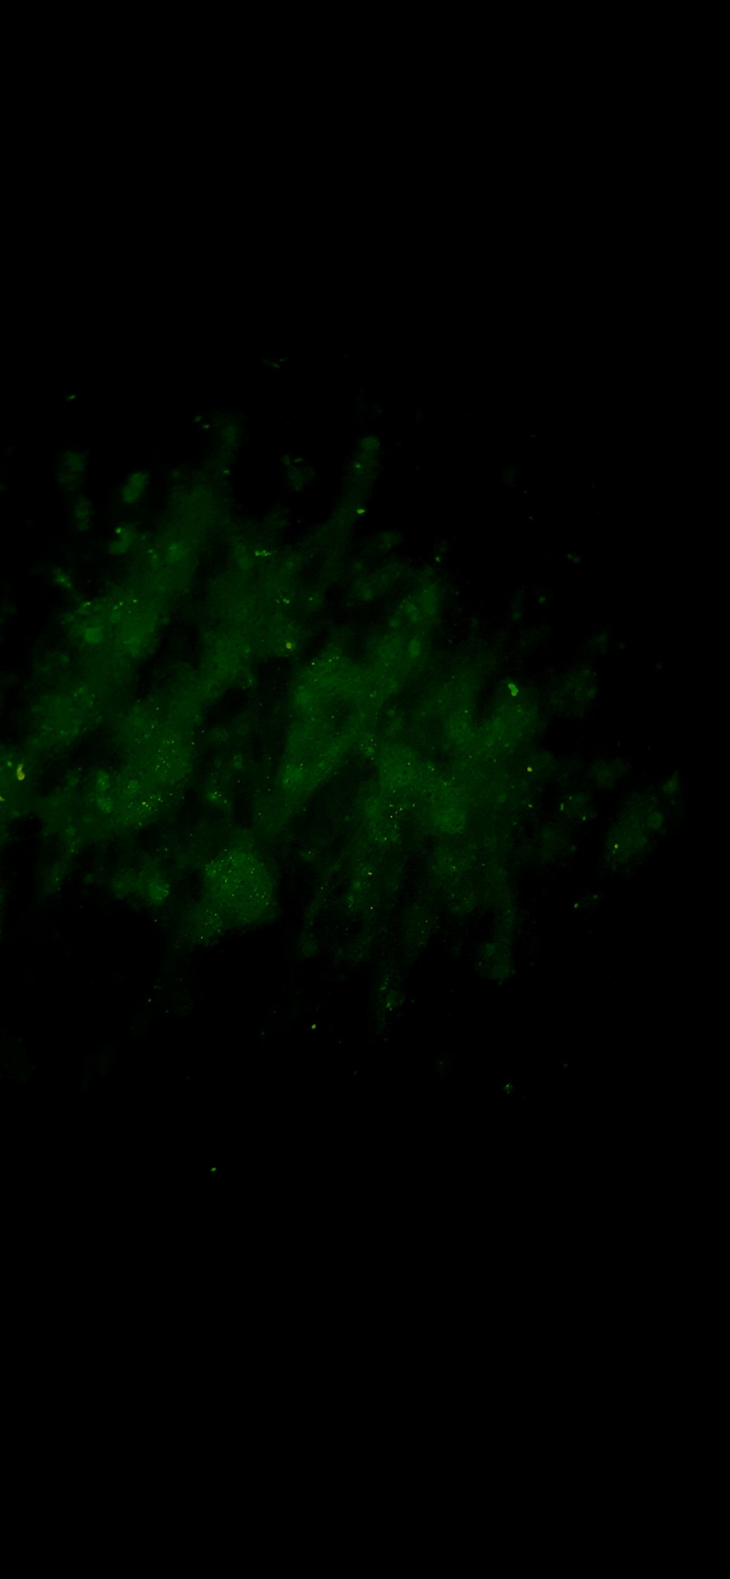

Fig.3. Immunofluorescence for rabies graded as 2+ (DFAT X 100)

Fig.4. Immunofluorescence for rabies graded as 1+ (DFAT X 100)

Summary
Grading of immunofluorescence from different parts of brain in 30 rabies positive dogs revealed that brain stem and cerebellum exhibited relatively higher fluorescence compared to other parts. Unilateral distribution of viral antigen observed in the hippocampus of rabid animals questions the reliability of DFAT on hippocampus as a confirmatory test for diagnosis of rabies. The study concludes brainstem and cerebellum as the recommended samples for diagnosis of rabies in canines by DFAT.
Acknowledgement
The financial support provided by Kerala Veterinary and Animal Sciences University, Pookode is acknowledged.
References
AravindhBabu R.P., Manoharan S., Ramadass, P. and Chandran, N.D.J. 2012. Evaluation of RT-PCR assay for routine laboratory diagnosis of rabies in post mortem brain samples from different species of animals. Indian J. Virol. 23: 392-396.
Chandran, D., Vijayan, N., Nair, N.D. and Suvaneeth, P. 2022. A comparative study of the immunofluorescence in brain, salivary gland and cornea in rabid carcasses. Int. J. Livest. Res. 12: 21-27.
Dumrongphol, H., Srikiatkhachorn, A., Hemachudha, T., Kotchabhakdi, N. and Govitrapong, P. 1996. Alteration of muscarinic acetylcholine receptors in rabies viral-infected dog brains. J. NeuroL. Sci. 137: 1-6.
Dupont, J.R. and Earle, K.M. 1965. Human rabies encephalitis – A study of forty-nine fatal cases with a review of the literature. Neurology. 15: 1023-1034.
God’spower, R.O., Kazeem, H.M., Kia, G.S. and Ponfa, Z.N. 2018. Heat induced epitope retrieval for rabies virus detection by direct fluorescent antibody test in formalin-fixed dog brain tissues. Open Vet. J. 8: 313-317.
Hemachudha, T., Laothamatas, J. and Rupprecht, C.E. 2002. Human rabies: a disease of complex neuropathogenetic mechanisms and diagnostic challenges. Lancet Neurol. 1: 101-109.
Raju, S., Saseendranath, M.R. and Tresamol, P.V. 2008. Comparing the sensitivity of detecting viral antigen in different parts of rabies suspected brain using fluorescent antibody test. J. Vet. Anim. Sci. 39: 18-19.
Rupprecht, C.E., Fooks, A.R. and Abela-Ridder, B. 2018. Laboratory techniques in rabies Vol 1. (5th Ed.). WHO, Geneva, 289p.
Shruthi, A., Prasanna, K.S., Sachin and Ajith, J.G. 2022 Astrocytic reaction in furious and paralytic forms of rabies with reference to GFAP expression in rabies positive dog brain samples. J. Vet. Anim. Sci. 53(2): 195-200.
Tepsumethanon, V., Lumlertdacha, B. and Mitmoonpitak, C. 1997. Sensitivity of fluorescent rabies antibody testing on samples taken from brain stem, cerebellum, cerebrum and hippocampus. Thai. J. Vet. Med. 27: 335-340.

